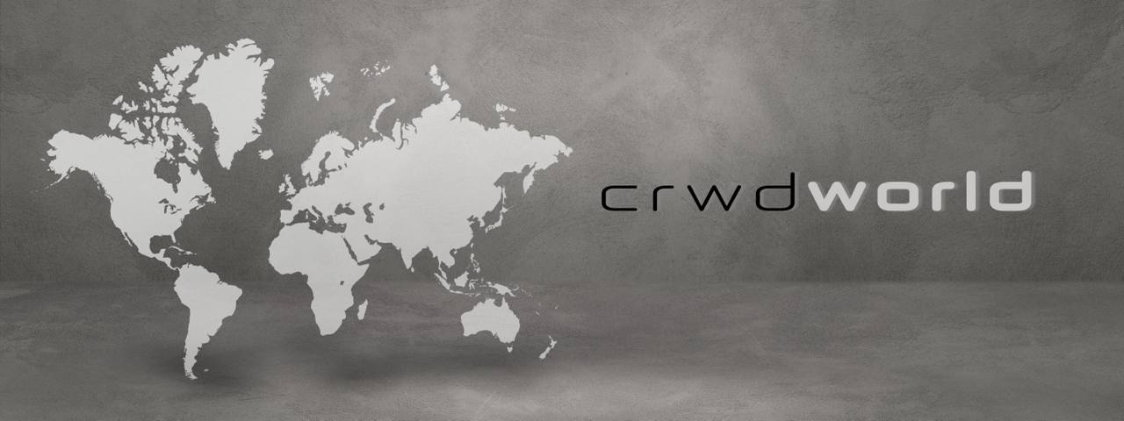

What if you could own a piece of the future?

What if you could build your next castle not on sand but on the bedrock of a modern blockchain ecosystem?

What if you had the opportunity to participate in a first-of-a-kind Initial Unit Offering?

By now you have heard of an IPO, DPO, or maybe an ICO. Each one of those involves risk to be sure, but the rewards can be tremendous if the right team is behind them. If you are reading this you have a chance to participate in an Initial Unit Offering.
- If you are an accredited Investor, you should click on the link below, Declare Your Independence.
- If you are not an accredited investor, you should click on it because you get a chance to see what is coming for you.

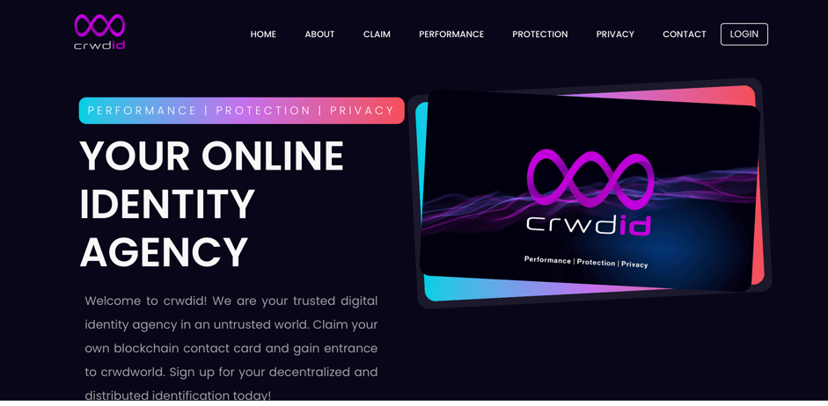

How we are going to connect to the internet and interact digitally is going to change. In my opinion, it is going to go one of three ways:
- A more intrusive version of today, where Big Technology Companies become more efficient at what they do and thereby subject all of us to their ideology and business model, which will include more bots and more invasiveness.
- The Blockchain Revolutionizes our online engagement by putting each one of us as owners of our own data and we define how, when, and where we interact. A truly semantic web.
- We land somewhere in the middle
July 4th is Independence Day!
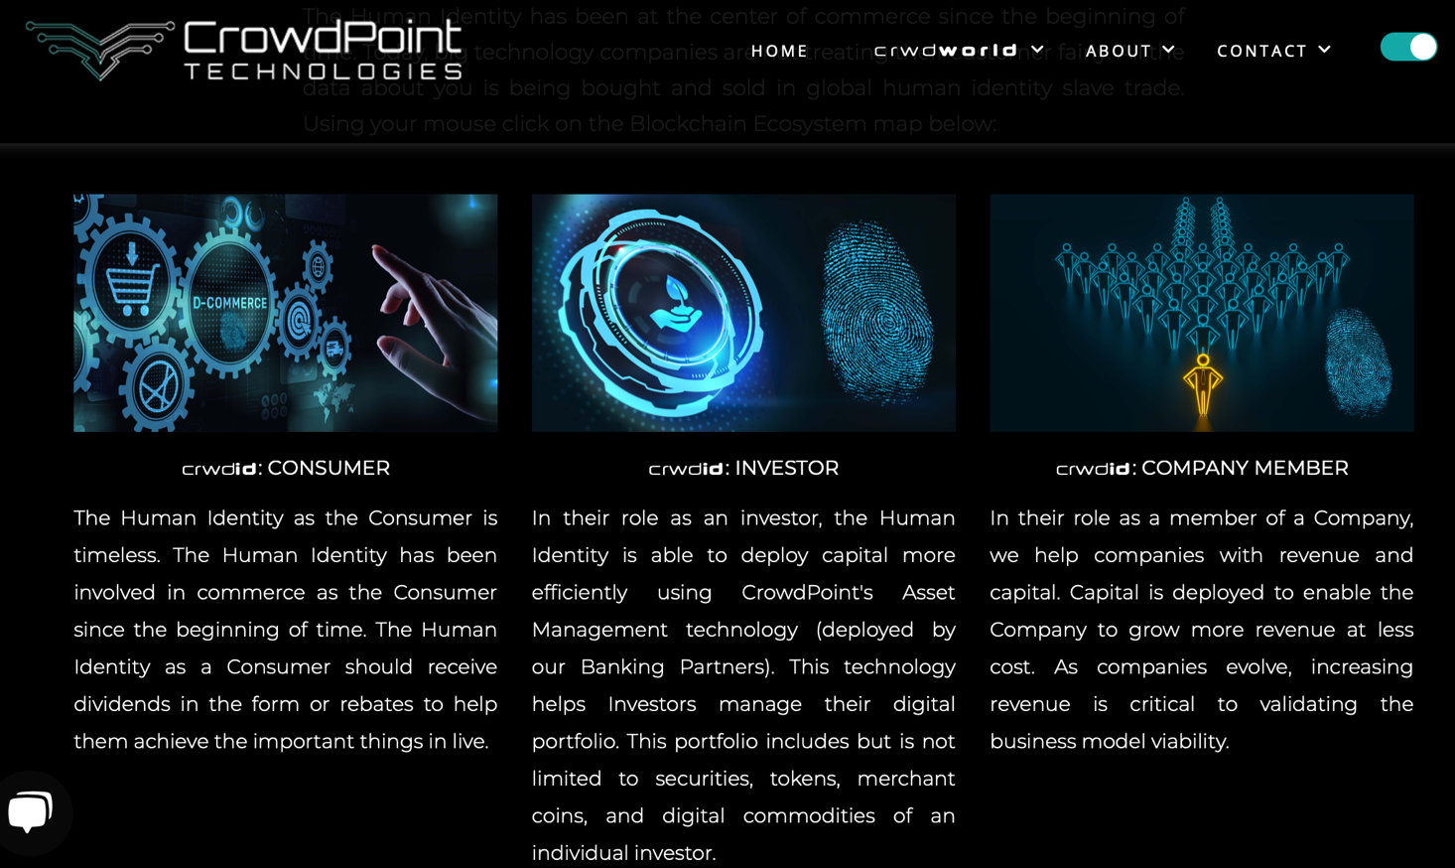
So, declare your independence from a global economy that doesn't share. Join us on crwdworld.

crwdworld is powered by our Vogon Blockchain. We built our blockchain as the key to creating a less expensive digital platform that enables all its participants to extract more value.

crwdworld empowers participants to share data and obliges others to reimburse the owner. This is the first step in creating a more sharing or collaborative economy built on the concept of shared resources. Given that Data is the new oil, sharing what powers the digital world is a good first step.

People are going to have to go back to their school days to remember what they forgot about the Buttonwood Agreement of 1792. Why the Wizard Oz was written. What happened in the early 1900s? Silver Backed Currencies worked in the past and they will work in the future.

The 4th of July is when we go back to what we learned in school. The greatness of the American Economy is when innovators and dreamers work together. Nexgen technology and our Vogon Decentralized Blockchain-powered cloud computing platform. It is where innovators and dreamers work together to define new kinds of Digital Asset Classes for a more efficient and sharing economy.

Join CrwdWorld today!
